***LAB # 01:***

***Name: Khizar Hayat Hashmi***

***Roll no: 2018-CS-160***

***Section: C***

**Q1: Airport check-in and security screening business model**

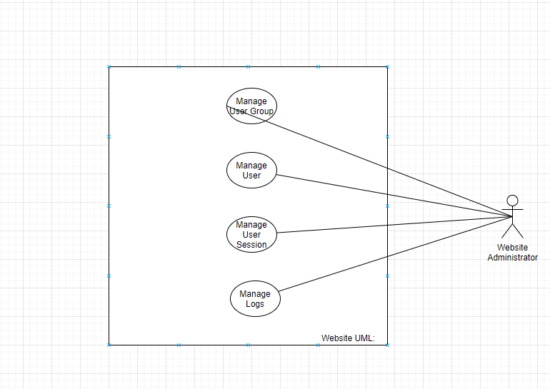

**Q2: Restaurant business model**

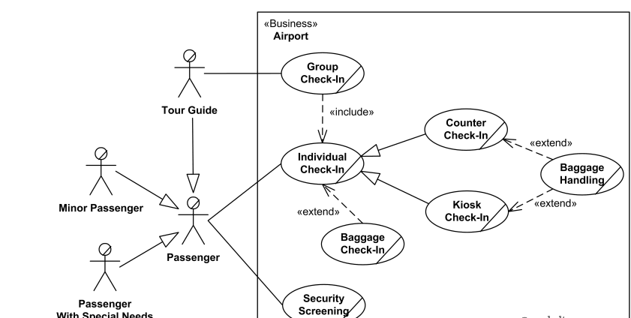

**Q3: Ticket vending machine**

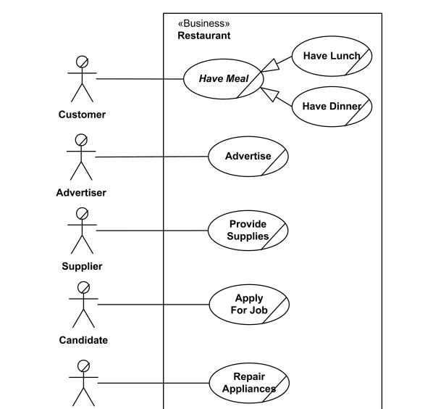

**Q4: Bank ATM UML use case diagrams examples**

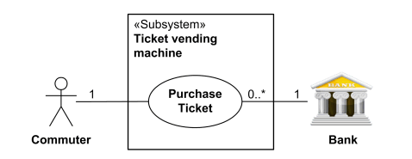

**Q5: Point of sales (POS) terminal**

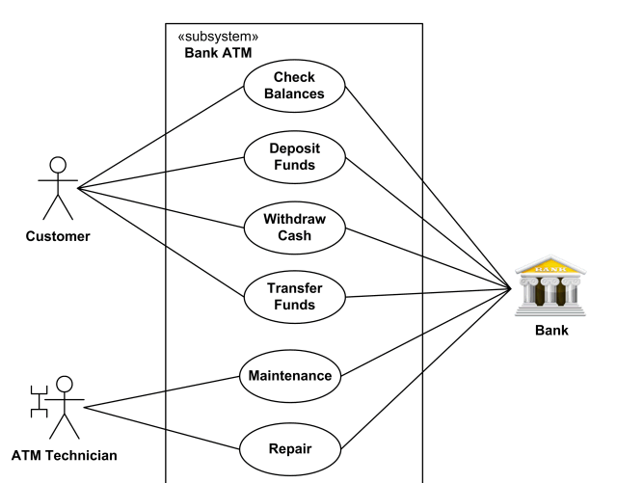

**Q6: e-Library online public access catalog (OPAC)**

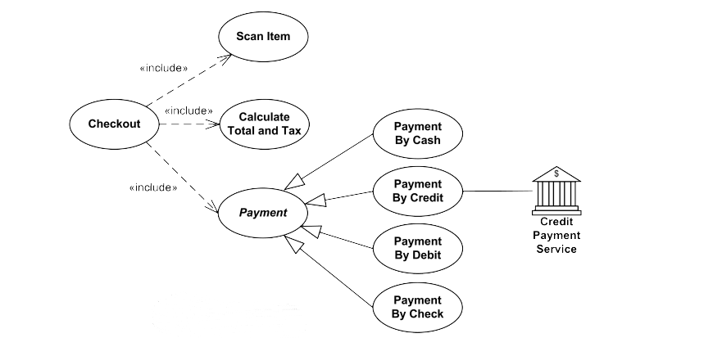

**Q7: Online shopping use case diagrams**

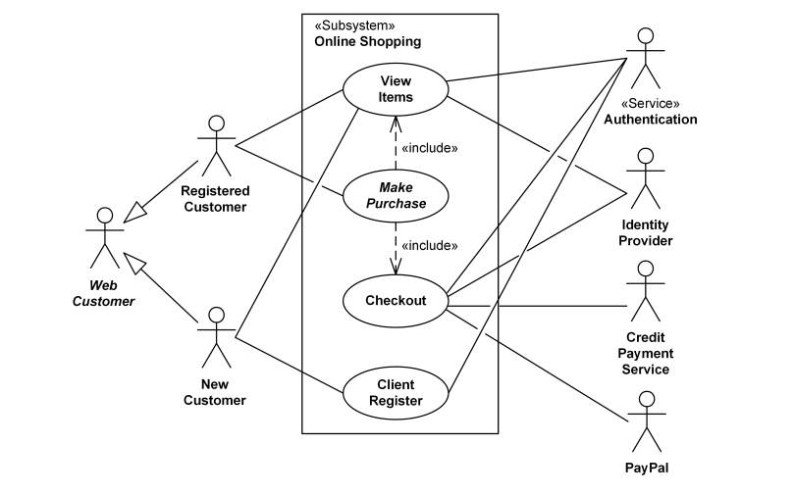

**Q8: Website administration**

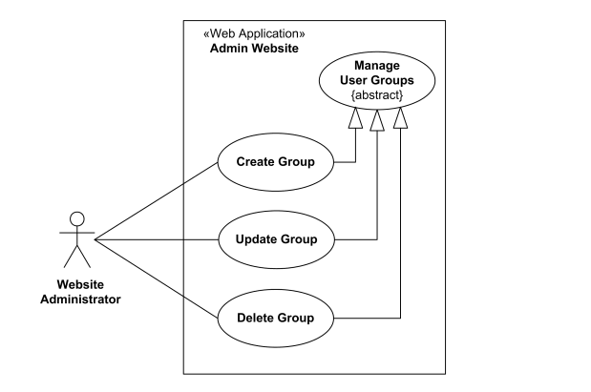

**Q9: Hospital Management**

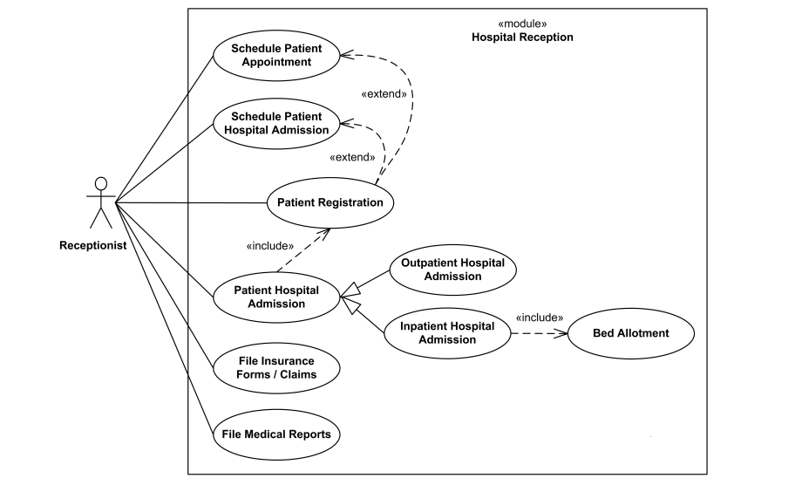

**Q10: Radiology diagnostic reporting UML use case diagram**

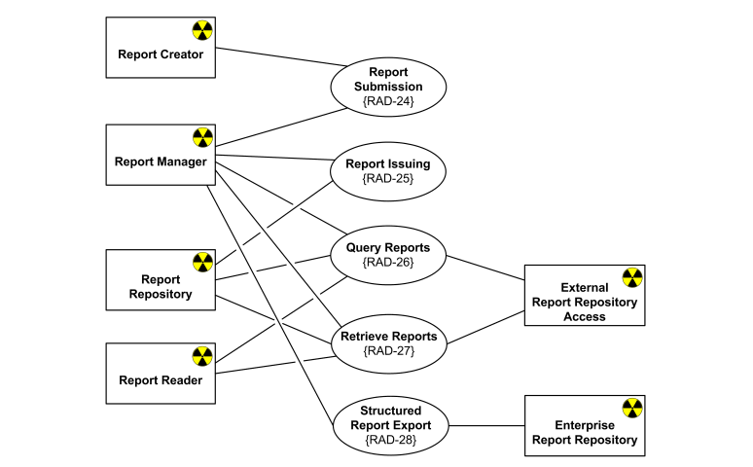

**Design a UML diagram for a centralized hotel reservation system which is working online, hotel desktop application and a customized application for travel agents.**

